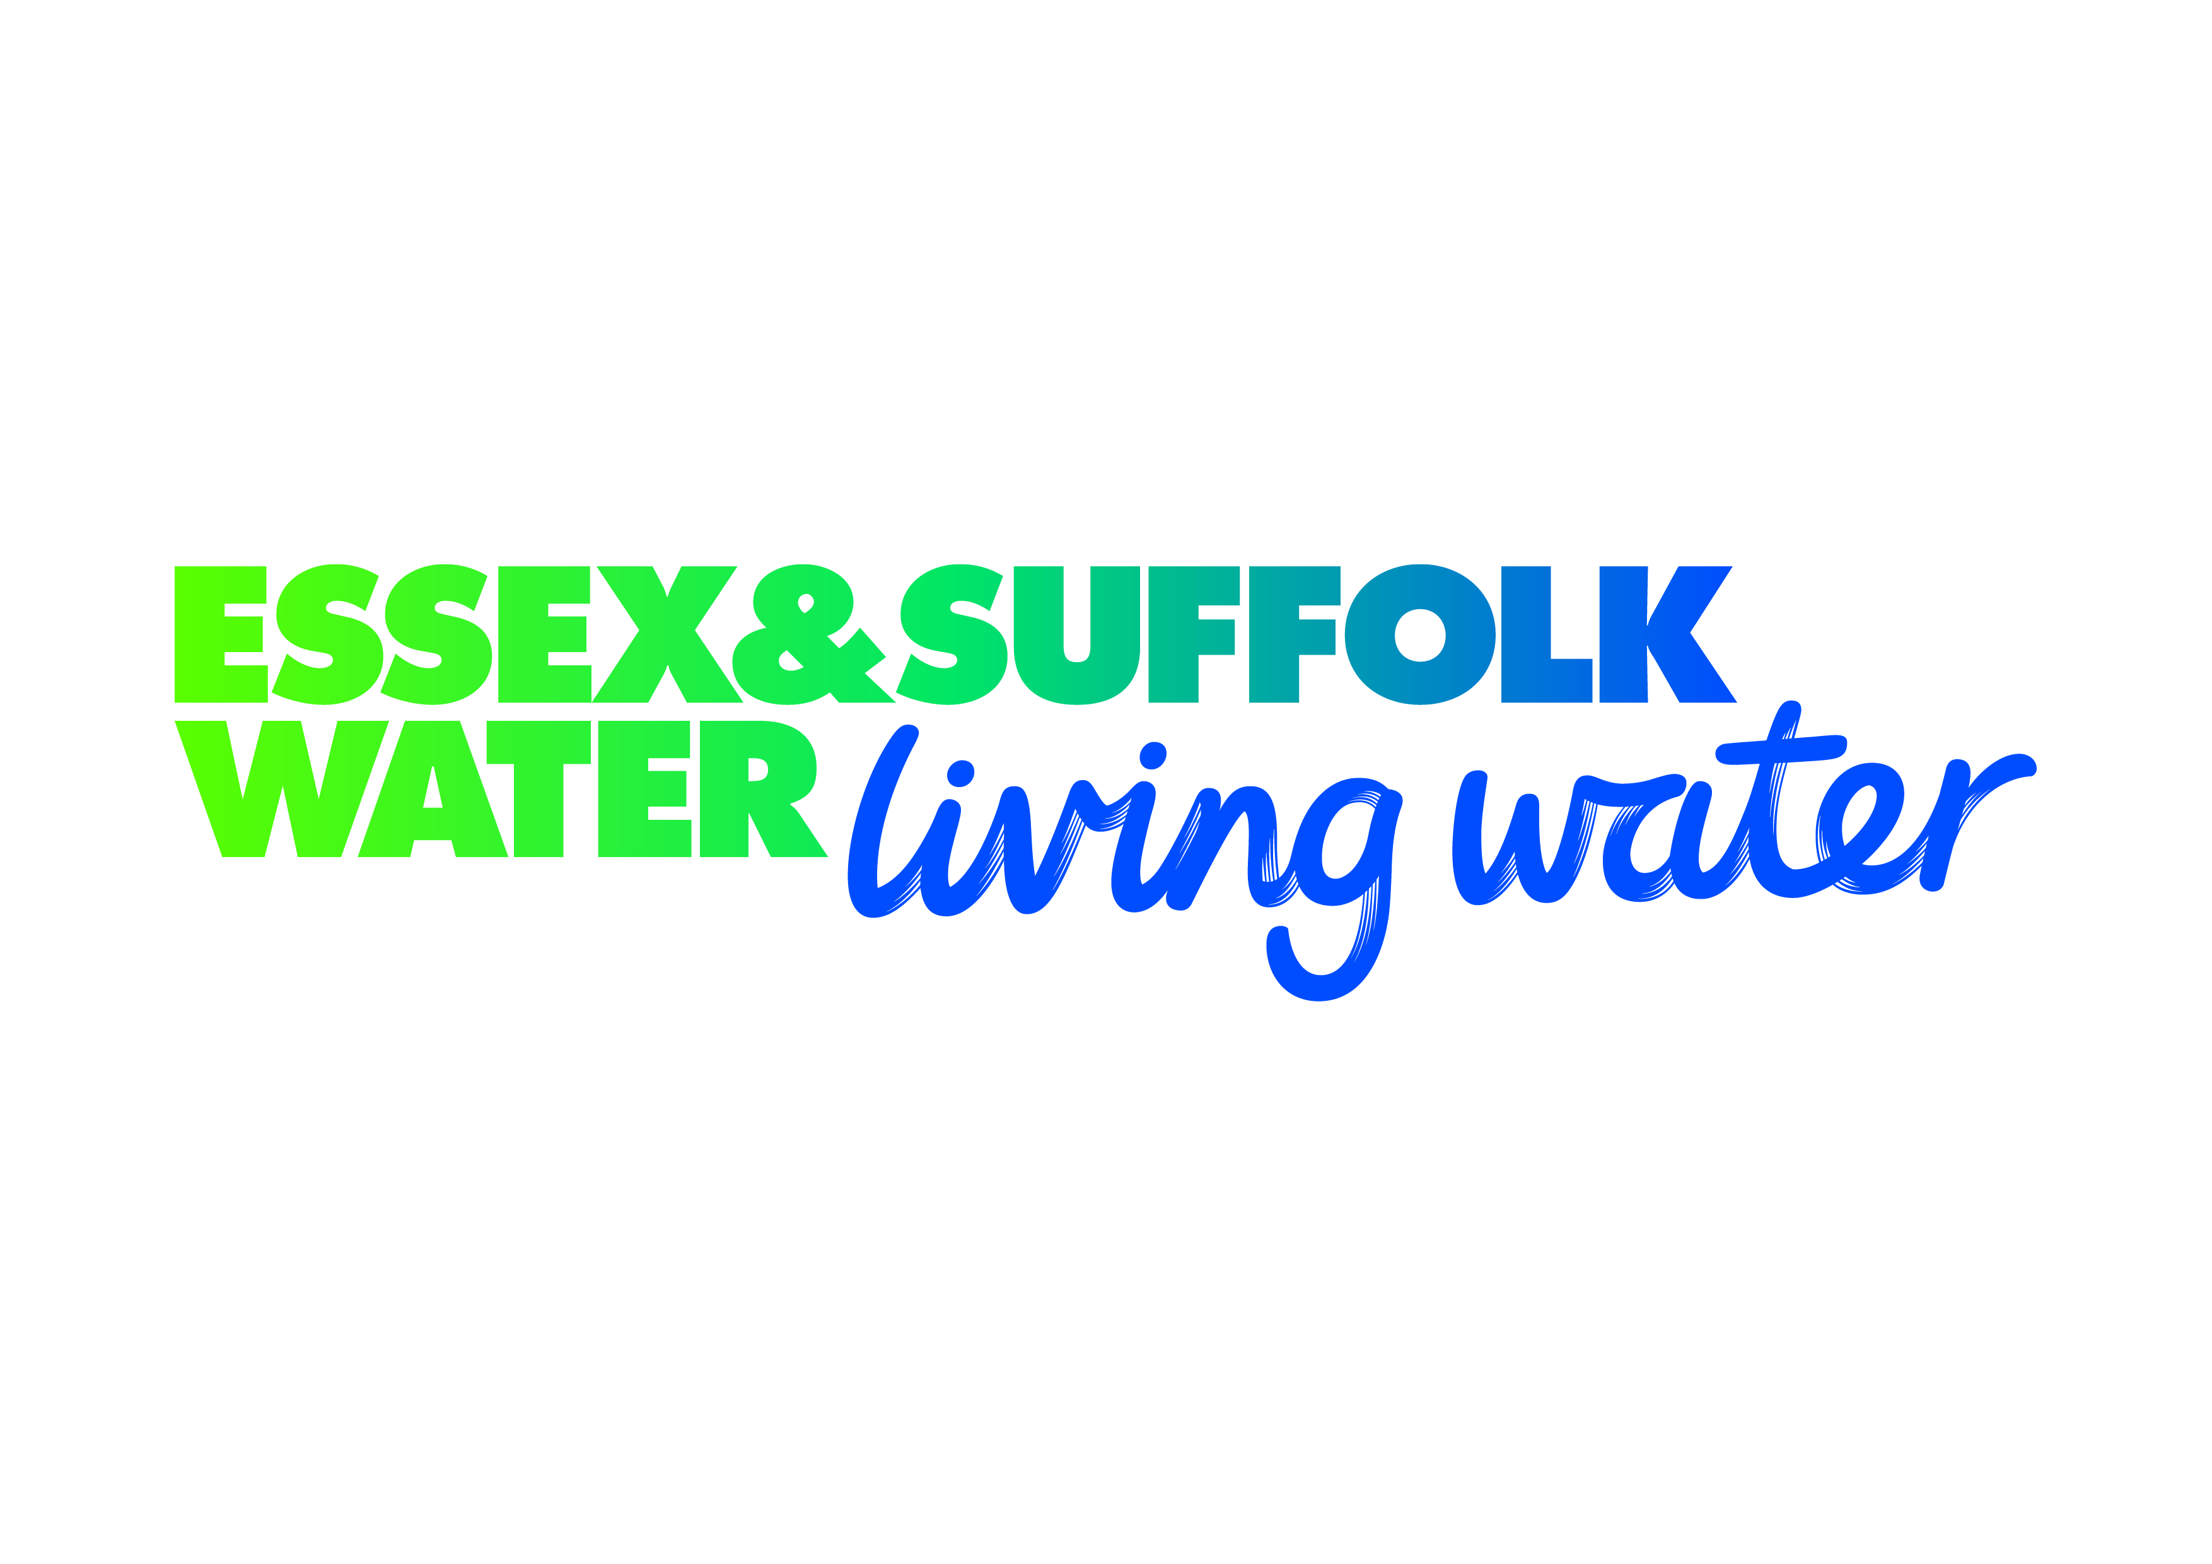

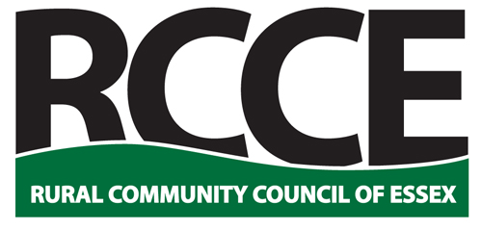

Rural Community Council of Essex
2020 Essex Village of the Year
Competition

Entry Form 2020
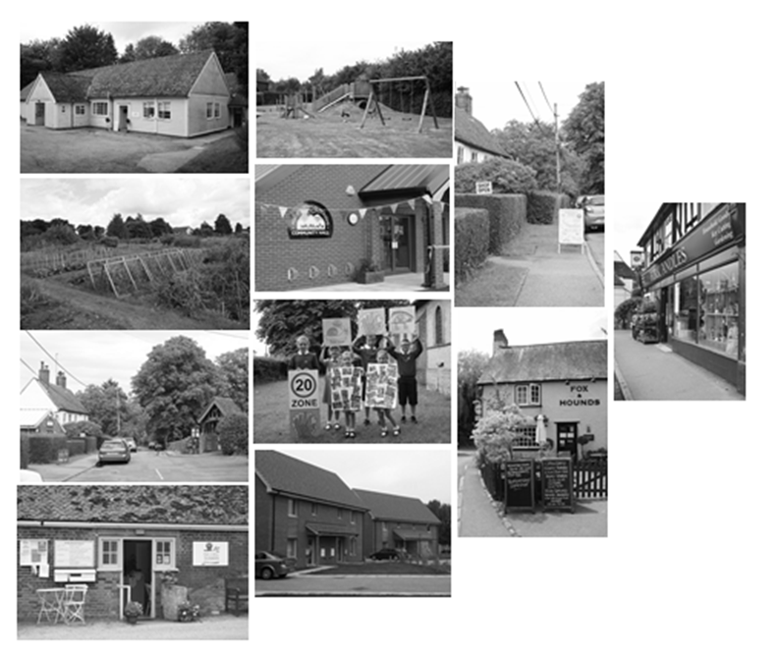
2020

Enter Online at www.essexrcc.org.uk

Village of the Year Entry Details

Village:

Population: | What is your Parish Council precept?  (This question is optional)

Sponsoring Organisation:

Contact
Name:
Address:

Email: Tel:

Please read the guidance notes in the ‘Entry Guidelines’ document before completing this form.

Village Profile

This is an opportunity for you to tell us about your community and how the people living and working there are involved in community life. Describe in your own words, what makes your village special.

On the following page, in no more than 500 words, please briefly explain to us about the organisations, activities and events that contribute most to community life in your village today.

There is no need to supply any additional information, documentation or photos.

Closing date for applications is: Friday 24th April 2020
Please describe in your own words, what makes your village special (in no more than 500 words).

