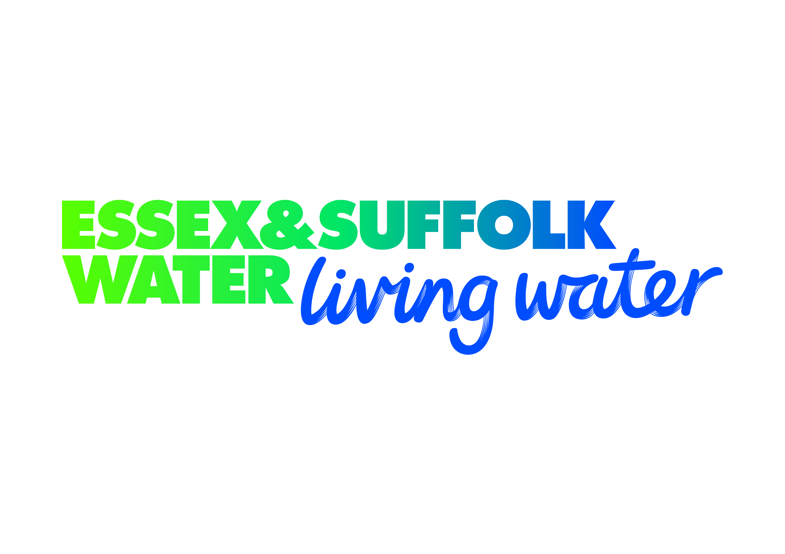

**Inkpen**

**Downie**

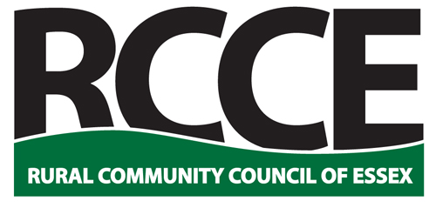



**Rural Community Council of Essex**

**2018 Essex Village of the Year**

**Competition**

Entry Guidelines 2018

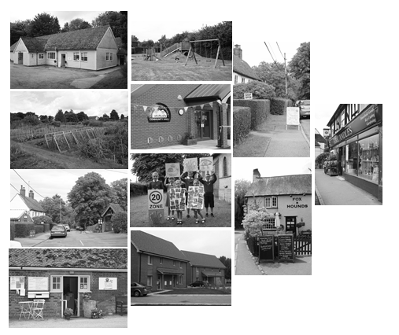

**Enter Online at** [**www.essexrcc.org.uk**](http://www.essexrcc.org.uk)

**Welcome to the 2018 Essex Village of the Year Competition**

Essex has a wide variety of villages, where local people are doing great things to strengthen community life. The purpose of the Essex Village of the Year Competition is to celebrate and reward these efforts. The competition has a proud tradition, but since refreshing two years ago, it has been encouraging to see many villages taking part that had never previously entered.

Please note an important change this year. We have amended the population categories in response from feedback from judges who felt it was difficult to make comparisons between very large and small villages. The new upper limit is 5,000, which means larger villages and market towns will not be eligible to enter this year. However, we are keen to recognise the work that goes on in these communities and are looking to introduce a new way of doing this in time for the 2019 competition.

**How to Enter**

Please complete the attached entry form, including the **Village Profile**, which consists of a single question.

**Please describe in your own words, what makes your village special in no more than 500 words.** There are no other questions and no need for you to supply any additional information, documentation or photos. A map of the village is NOT required.

In completing the profile, please briefly tell us about the organisations, activities and events that contribute most to community life in your village today. Please do not feel you must cover all of the following, but points you might want to consider include:

* How is a sense of community achieved?
* Do you hold annual village events?
* Is there a good mix of local clubs and groups?
* Do you have local businesses that support community activities like youth sports teams?
* Do volunteers help care for the local environment?
* Is the community involved in running any local services – e.g. community shop, pub or transport scheme?
* Do you have a community magazine or website?
* Are there any new community initiatives in progress?

We will make allowances for the size of villages and accept that in smaller communities activities will be shared with neighbouring villages. Please also give thought to who completes the entry, someone who knows the community well can often provide valuable insight into community activity.

**Submitting Your Entry**

Entries can be made either on line or by post. If submitting your entry on line, all documentation can be accessed by visiting the RCCE website [www.essexrcc.org.uk](http://www.essexrcc.org.uk) . Entries can be sent to enquiries@essexrcc.org.uk

If submitting your entry by post, please send the completed entry form to Sara Ward, Rural Community Council of Essex, Threshelfords Business Park, Inworth Road, Feering, Essex CO5 9SE.

The deadline for entries is **Friday 4th May 2018.**

For further information please contact Sara Ward on 01376 574330 or email [enquiries@essexrcc.org.uk](mailto:enquiries@essexrcc.org.uk)

**The Judging Process**

Judging will be based around each village’s Profile and will focus on the following themes:

**Community Facilities and Activities**

**Businesses and Services**

**Environment and Sustainability**

**Community Information**

**New Initiatives and Future Plans.**

**Prizes**

Thanks to the generosity of our sponsors - Essex & Suffolk Water and Inkpen Downie Architecture and Design Ltd - we are able to offer the following prizes:

1st Prize: £500 and the Essex & Suffolk Water Shield.

2nd Prize: £200

3rd Prize: £150

There will also be 5 class winners receiving £150 each. These will be based on the following population categories:

Class I 2501 to 5000

Class II 1601 to 2500

Class III 801 to 1600

Class IV 501 to 800

Class V less than 500.

*(Note 1. The judges will arrange (through the named contact for each entrant) a suitable time for their visit, when they will meet with representatives of the community (we suggest a minimum of 2, maximum of 4 people). The community representatives will answer questions and show the judges key points of interest in the village relevant to the competition themes. It is expected that the judges’ visit will be 1 – 1 ½ hours maximum).*

*(Note 2. The marks and feedback from the 1st round visits will then be reviewed by a panel and a shortlist of villages selected for the final round of judging.)*