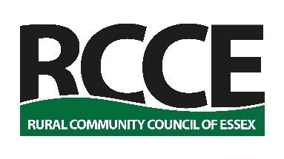

Rural Housing Enabler
Person Specification

Characteristics and competencies will be assessed through a combination of application form and interview.

Core competencies | Key characteristics
Organisational and personal skills, literacy | - Organised and with a high level of self-motivation.  - Flexible. Available to manage own time effectively and work anti-social hours (evenings, weekends) as necessary.  - Understanding of the issues faced in rural areas.  - Able to drive with access to a car for work.  - Functionally literate, able, and willing to keep written and electronic records.  - Capable computer user, including email, word processing, social media, basic Excel spreadsheets.  - Naturally a solution orientated person; capable of understanding challenges and works to find solutions.
Communication skills | - Able to listen effectively, empathise with others and identify verbal and non-verbal communication signals.  - Respectful, open, and sensitive to others. Positively committed to anti-discriminatory practice, equality and social action.  - Has personal integrity, understands confidentiality and Data Protection issues.
Influencing, Enabling and Empowering | - Able to understand power and influence. Interested in enabling and empowering local communities.  - Dynamic, motivated, energetic and creative with a can-do approach to problem-solving.  - Able to understand and deal with competing agendas.  - Understands the context and practice of community action.
Relationship building | - Self-aware, adaptable and responsive to others.  - Able to work constructively in team situations.  - Adaptable, diplomatic and able to relate to a wide range of people. Understands and has skills to manage partnerships and relationships.  - Has a versatile and flexible approach to work.  - Demonstrates insight, experience and resourcefulness.

Useful Experience and Skills:

- Understanding of the work of parish and town councils.
- Understanding of Affordable Rural Housing, planning. policies or housing.
- Community action or community development experience.
- Experience of volunteering.
- Group facilitation.
- Customer service and public relations.
- Social and market research.
- Organising events and/or delivering training.

